Introduction to Programming II project log

Project title: | Coursework – Data Visualisation
Topic: | Week 17 and 18: Debugging and Stability tests
What progress have you made on this topic?
I inspected each Data Visualisation and checked their performance.

Tech Diversity: Race – Donut Chart
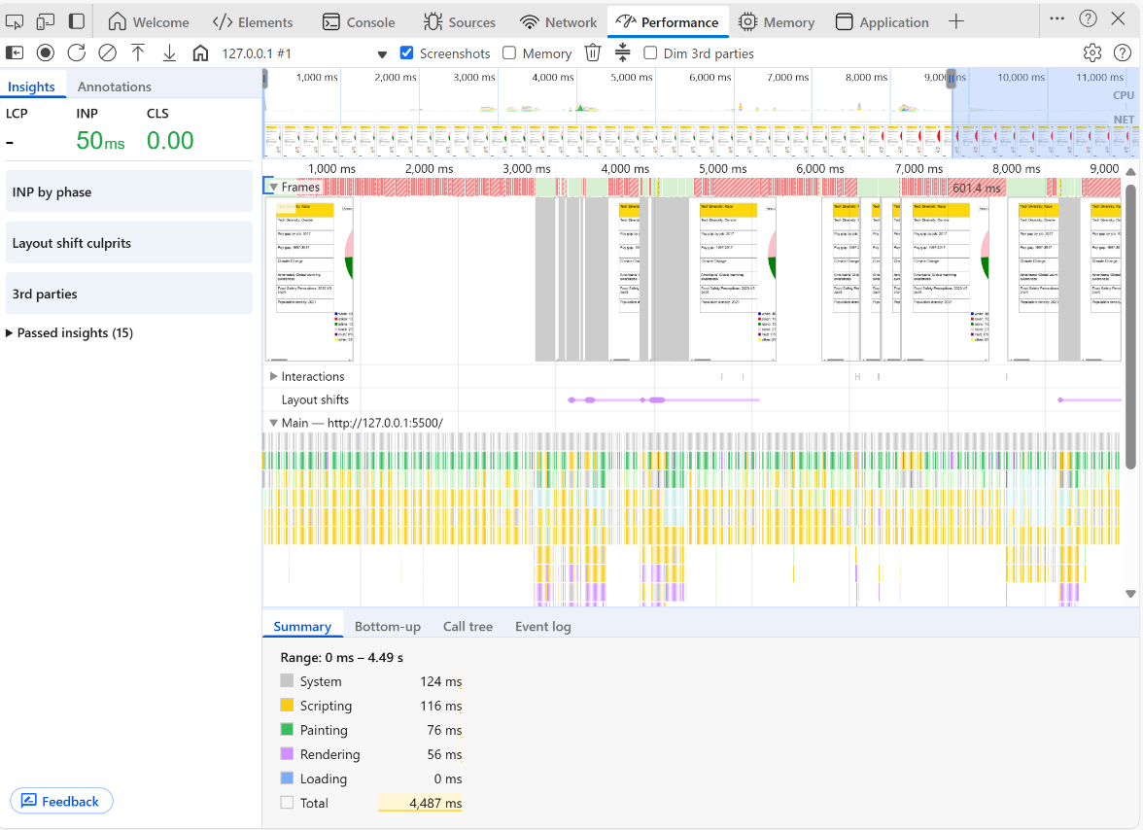
Performance:
INP: 50ms Dashboard responds quickly to user interactions
CLS: 0.00 No layout shifts, ensures stable rendering and good UX

Rendering Efficiency:
Scripting, painting, and rendering times are all below 150 ms, indicating optimised SVG and D3.js rendering. This ensures smooth frame progression, responsive JavaScript execution, and lag-free visual updates.

American’s Global Warming awareness – Waffle Charts
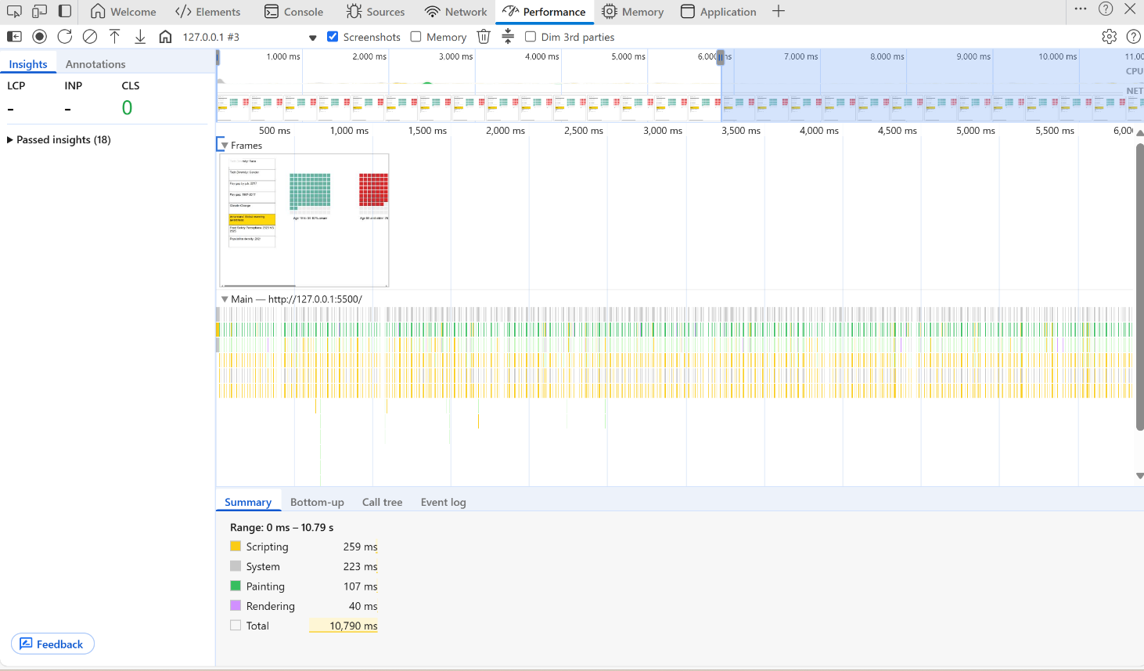
Rendering Efficiency:
Scripting: 259ms Within acceptable range
Painting: 107ms Smooth rendering of SVG elements, no visual lag detected.
Rendering: 40ms Highly efficient layout and style recalculations.

These metrics confirm that the waffle charts perform reliably under real-world conditions, with no jank or layout instability. The visualisation remains responsive and accessible.

Food Safety Perceptions: 2023 VS 2025 – Circle Diagram
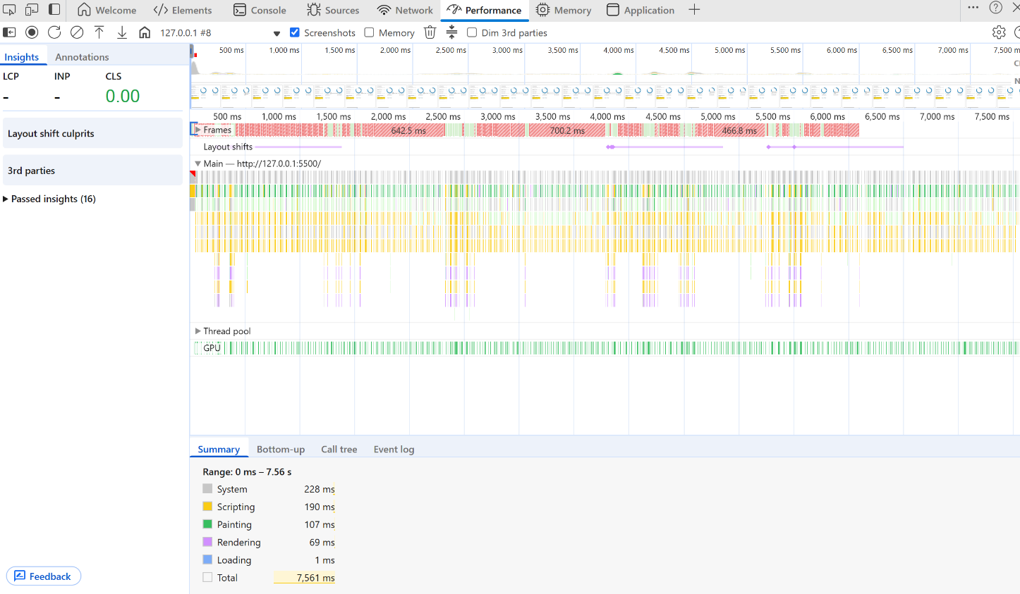
Rendering Efficiency:
Scripting: 190ms Efficient JS execution, suggests optimised data parsing and event handling.
Painting: 107ms Smooth rendering of SVG elements, no visual lag detected.
Rendering: 69ms Highly efficient layout and style recalculations.

Population Density: 2021 – Heat Map
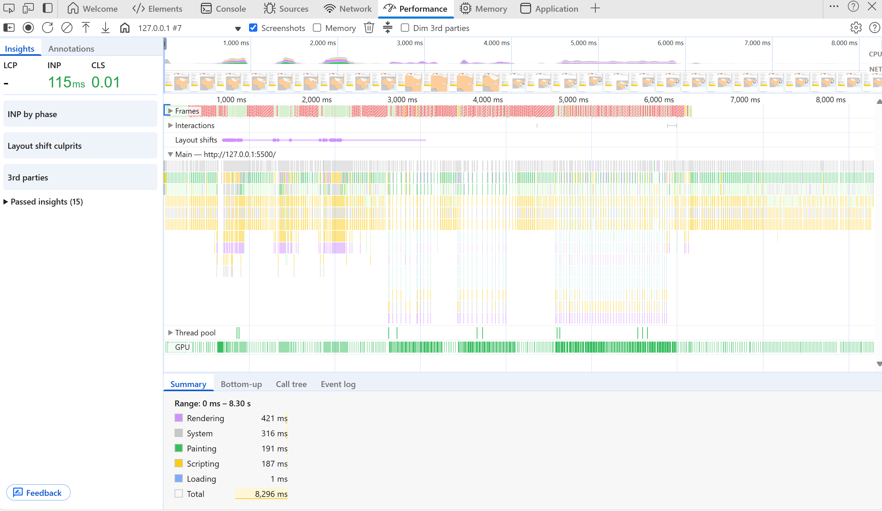

Performance:
INP: 115ms Dashboard responds quickly to user interactions
CLS: 0.01 No noticeable layout shifts, ensures stable rendering and smooth UX.

Rendering Efficiency:
Scripting: 187ms Efficient JS execution, suggests optimised data parsing and event handling.
Painting: 191ms Smooth rendering of SVG elements, no visual lag detected.
Rendering: 421ms Moderate complexity

Summary
All feature enhancements and polishing efforts were validated through targeted debugging and performance testing. Metrics such as INP, CLS, scripting, rendering, and painting times remain within optimal ranges, confirming that recent changes did not introduce regressions. The dashboard continues to perform responsively and render stably, ensuring a smooth and accessible user experience.
What problems have you faced and were you able to solve them?
No critical issues were encountered during development. However, extensive debugging and stability testing were conducted to proactively ensure that new features, such as chart resizing, legend positioning, and tooltip behaviour, did not introduce regressions.
Performance audits confirmed that all metrics remained within optimal ranges, and layout integrity was preserved across visualizations

What are you planning to do over the next few weeks?
I plan to conduct additional stability testing to ensure that all visualizations remain performant and error-free across interactions.
I’ll also begin usability testing to validate the overall user experience, focusing on clarity, accessibility, and intuitive navigation. These tests will form the final review and verification stage before submission, confirming that the dashboard is both technically sound and user-friendly.

Plan:
- Go through all the visualisations to check for possible errors (eg. Glitch, visualisation not displaying)
- Conduct a survey, the System Usability Scale (SUS), to 3 people, to test my data visualisations

Are you on target to successfully complete your project? If you aren’t on target, how will you address the issue?
I am on target to successfully complete my project. No issues have been identified at this stage of debugging and testing. Assuming continued stability, my project will be ready for submission after the final round of performance and usability testing.

